The Tale of Africa

Africa is a mineral rich diverse country with plenty of scope to prosper and flourish. But due to several difficulties the country always lags behind in terms of wealth creation and management, more than that, human resource management. In terms of growth, Africa is lagging behind several continents that highlights its miserable state. Due to consistent outbreak of diseases that are dangerous, many people in Africa die young due to coming in contact with such illnesses, certain disease outbreaks like, Ebola and HIV AIDS, have impacted Africa in a very miserable way.

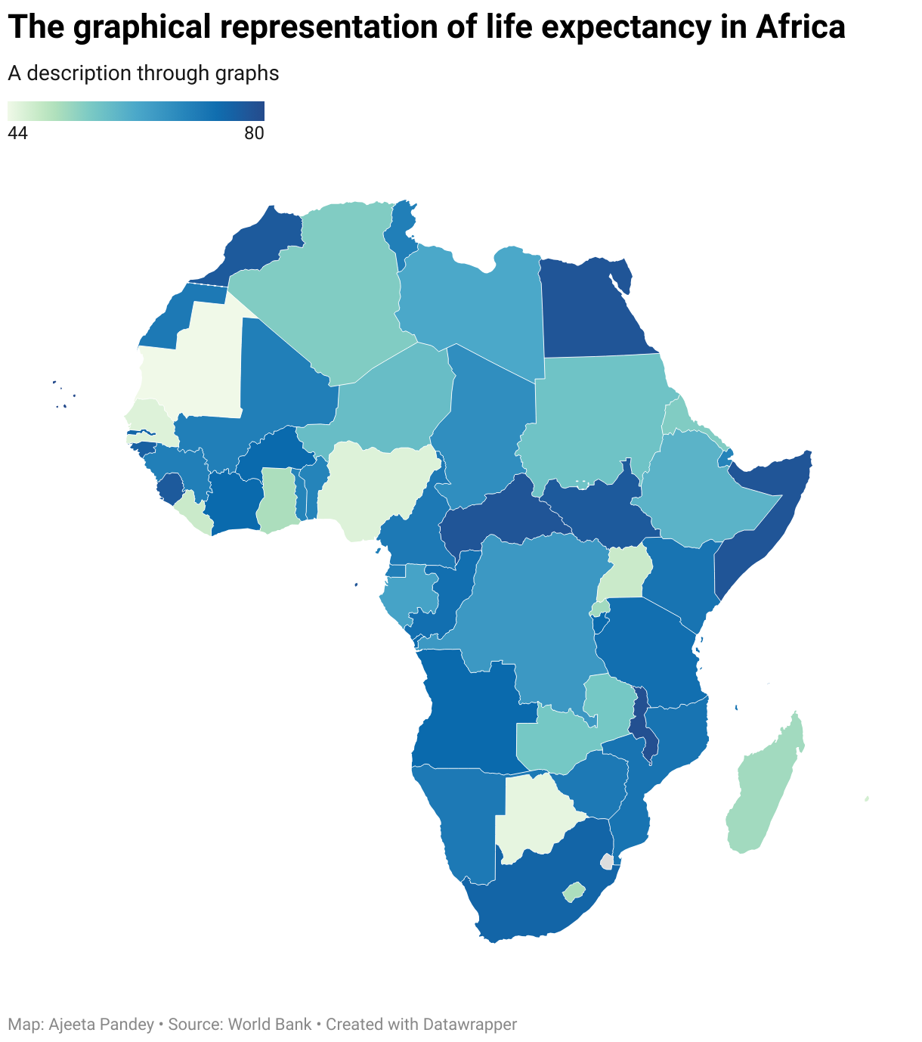

So this graph describes the ailing state of Africa, where almost the entire Africa is affected by a low life expectancy, more so, this level of life expectancy is generally a result of less access to good medical conditions. This means the entire Africa is somewhere facing an issue, where people are not getting access to good health.

The per capita GDP and Population explosion

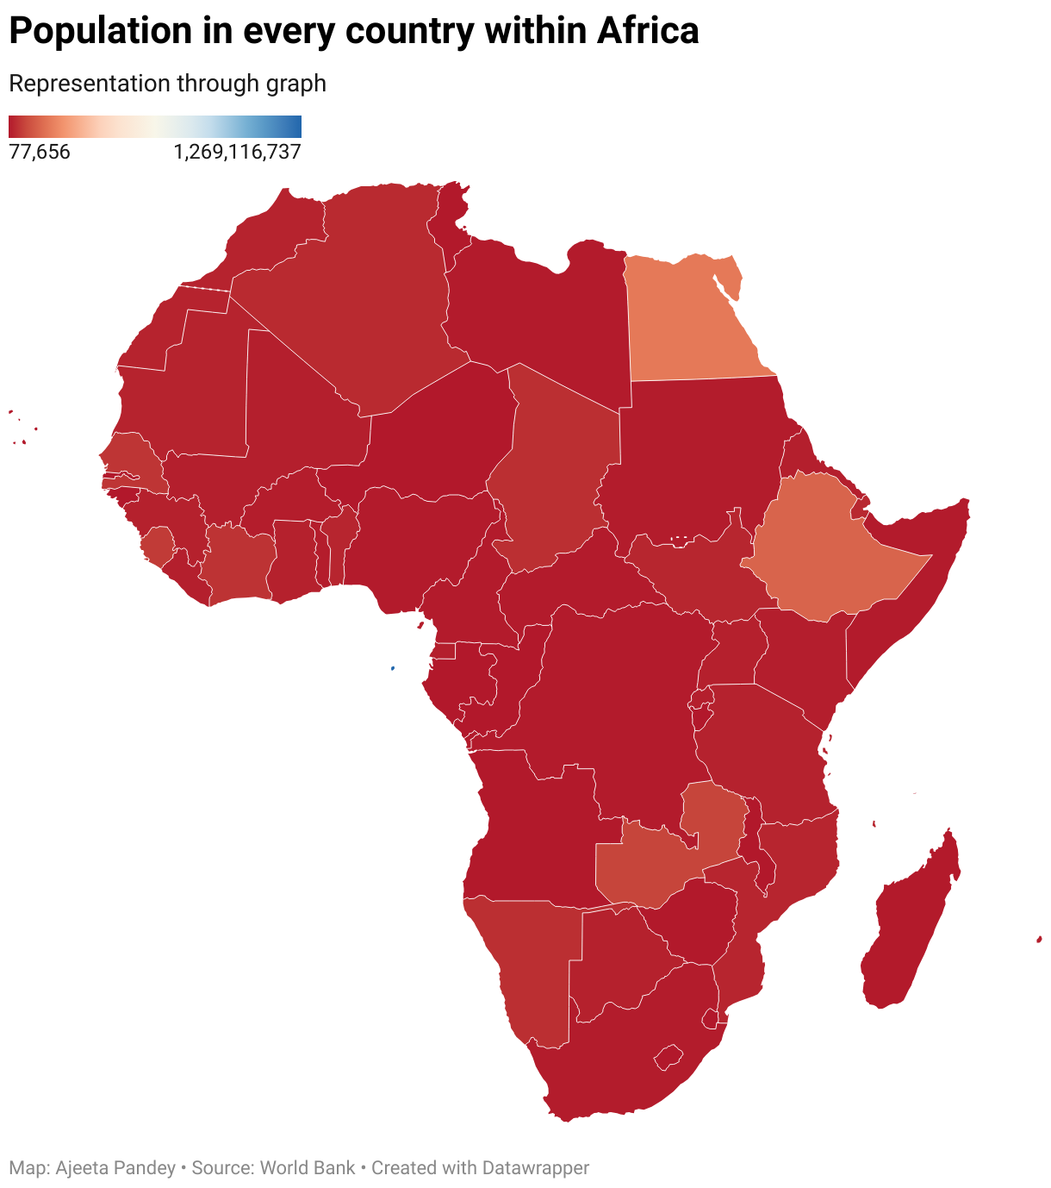
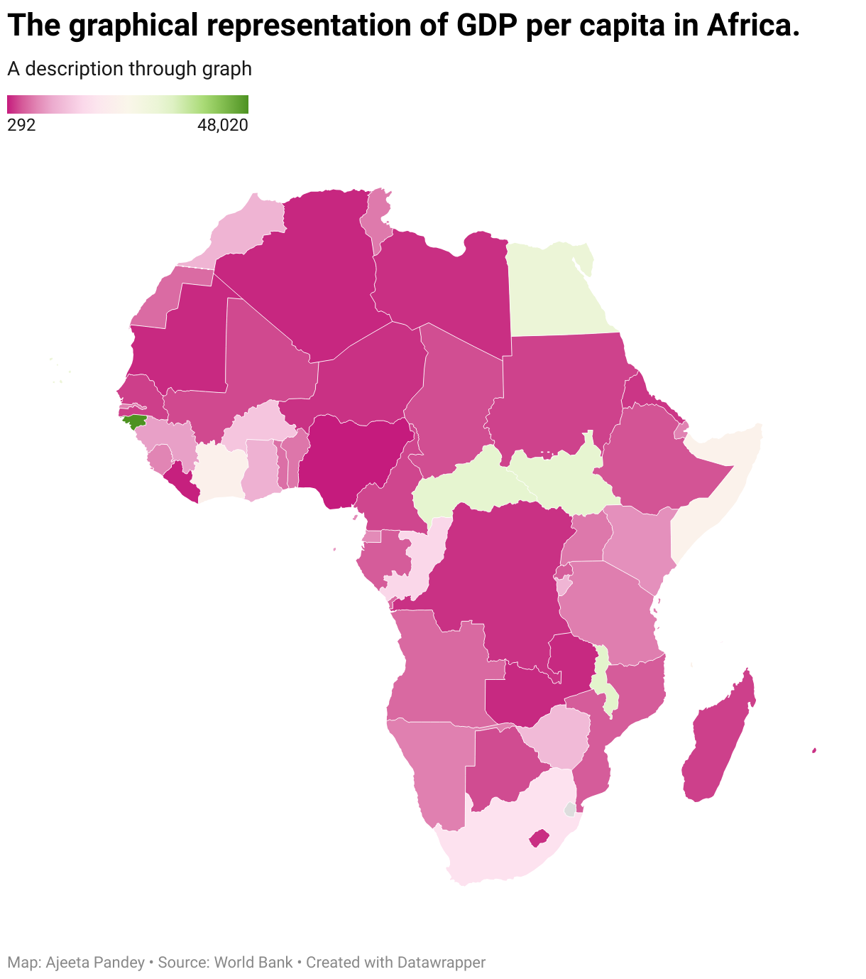

The problem in Africa becomes even more miserable when the per capita GDP is compared with the existing population within the continent. The gap is both challenging and daunting, as such figures point in the direction of rising poverty in Africa. According to the world bank, 30.9% of Africans live in extreme poverty, which raises alarm.

This problem needs to be handled in the right way until it takes Africa in darkness, although repeated efforts of the World Bank, UN, UNICEF, is bringing change in Africa.

Let’s take a look at complete table

This entire table table gives an insight on Africa, and my concluding remark in this story through data.
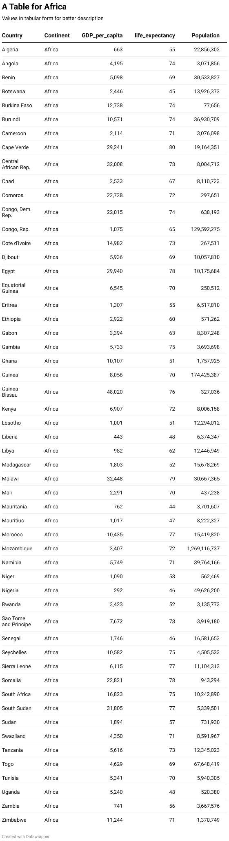

By Ajeeta Pandey.

